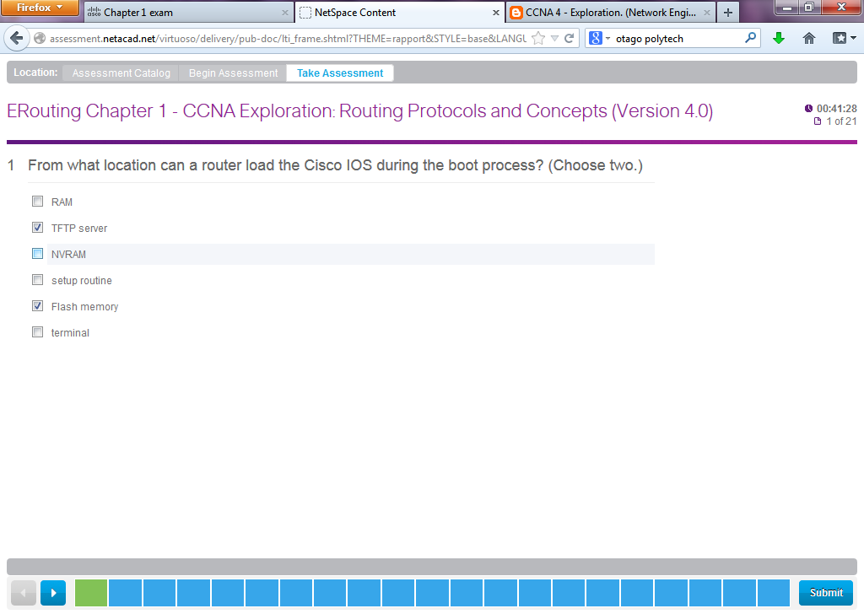

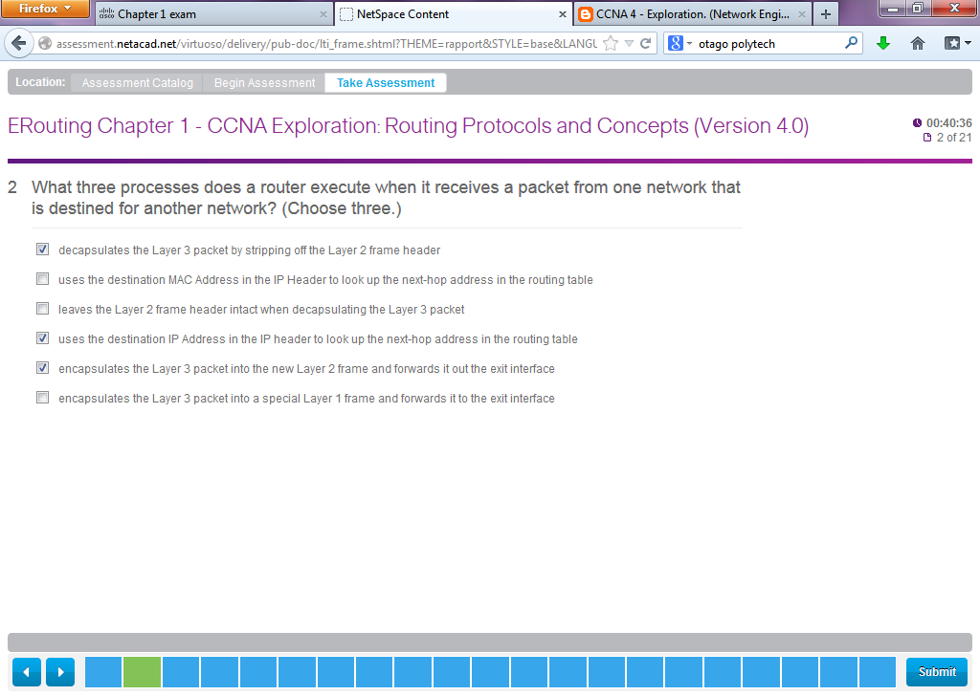

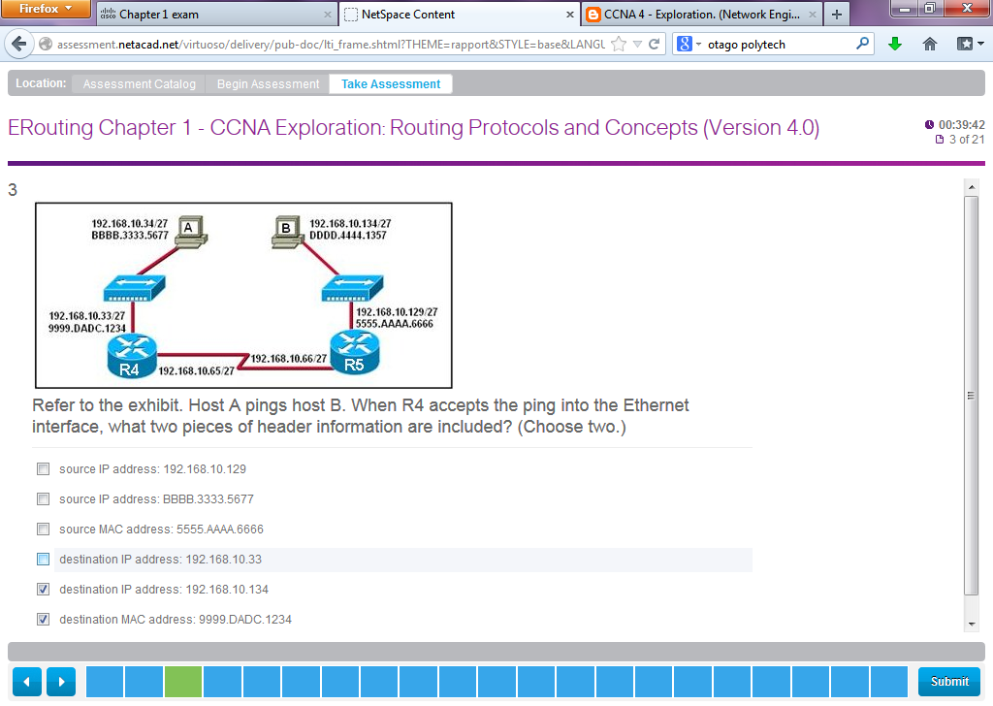

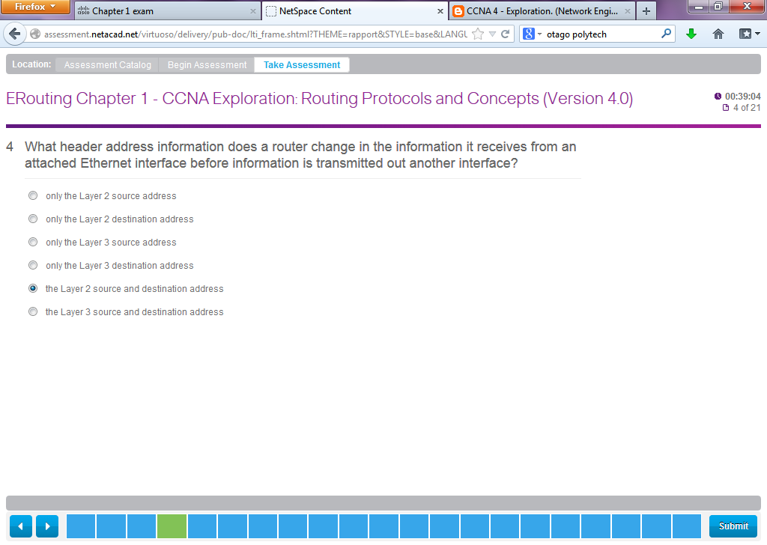

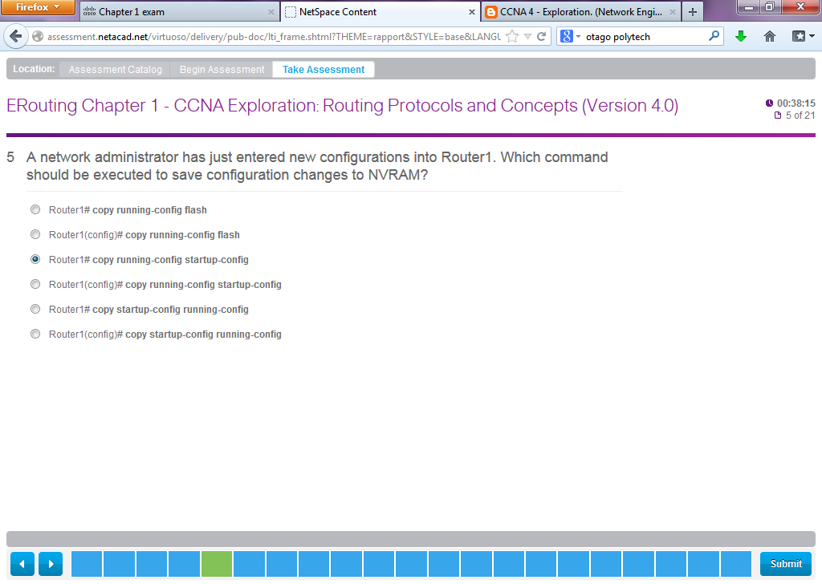

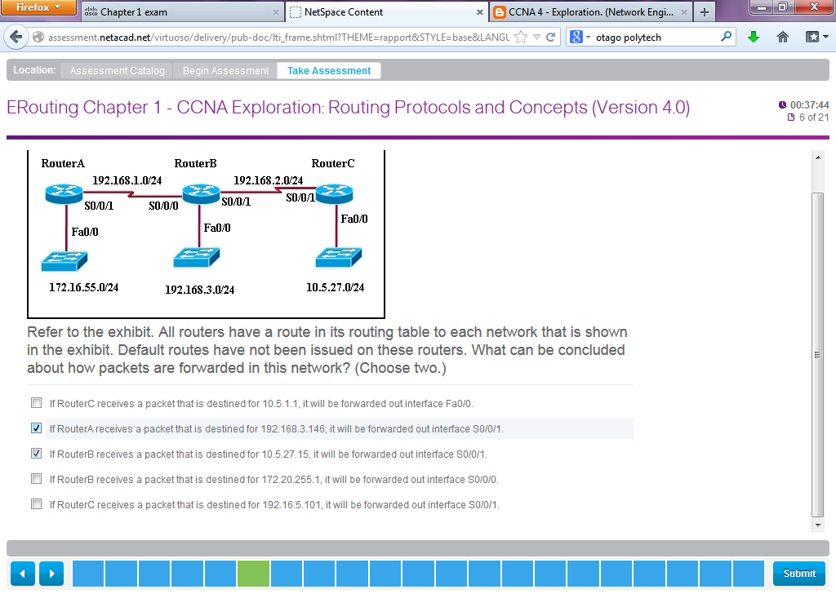

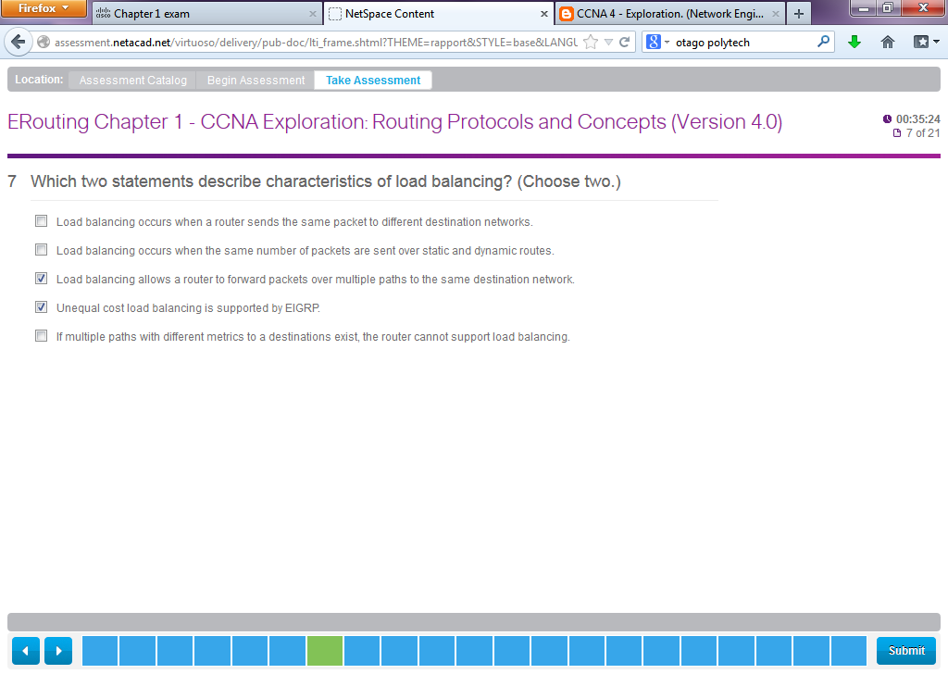

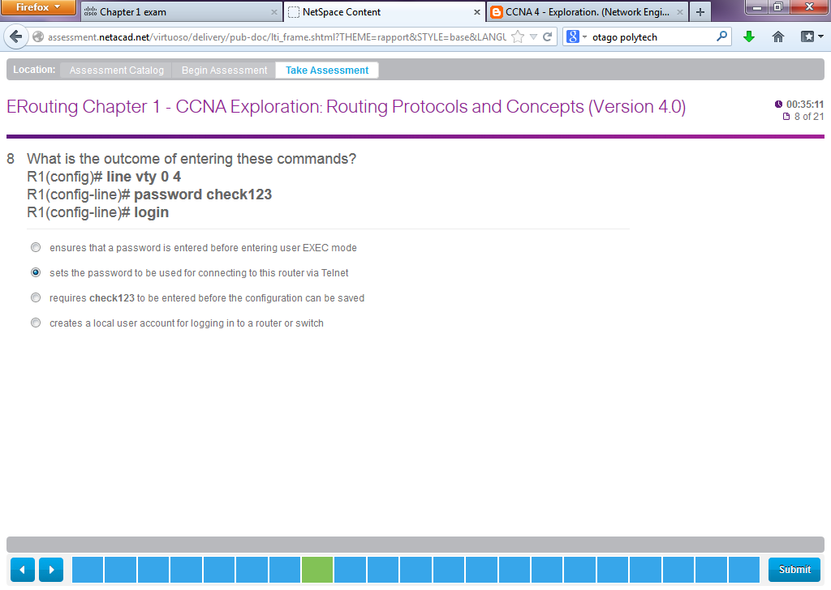

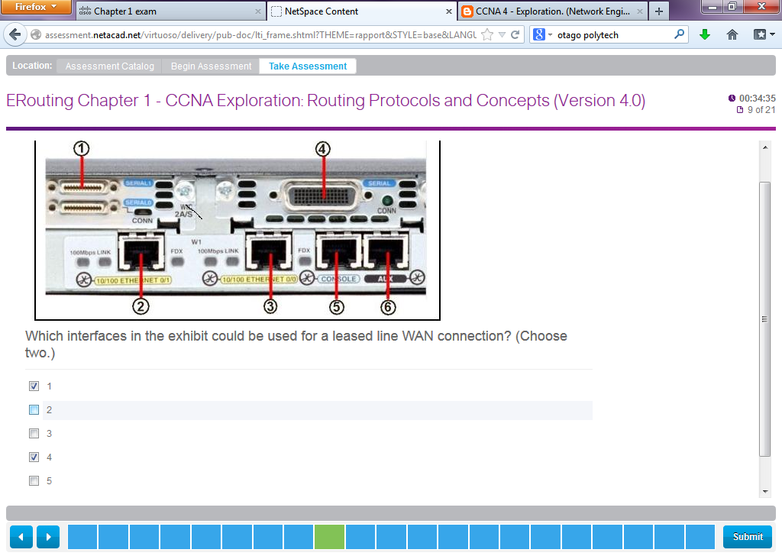

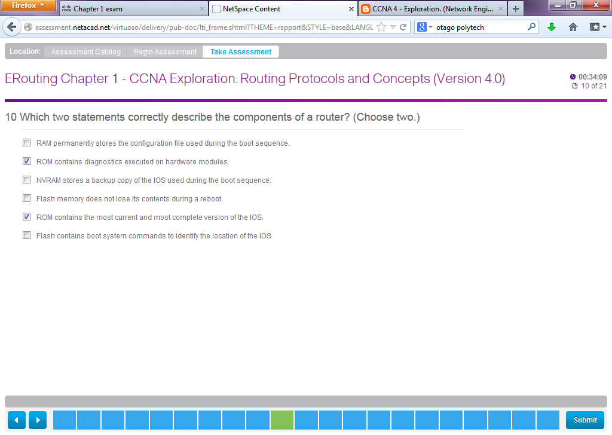

Correct Answer

6. Which two statements correctly describe the components of a router? (Choose two.)

--> ROM contains diagnostics executed on hardware modules.

--> Flash memory does not lose its contents during a reboot.

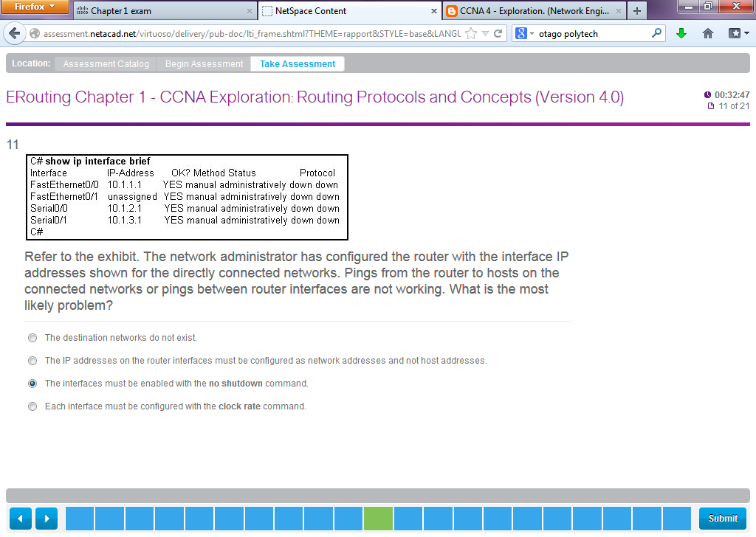

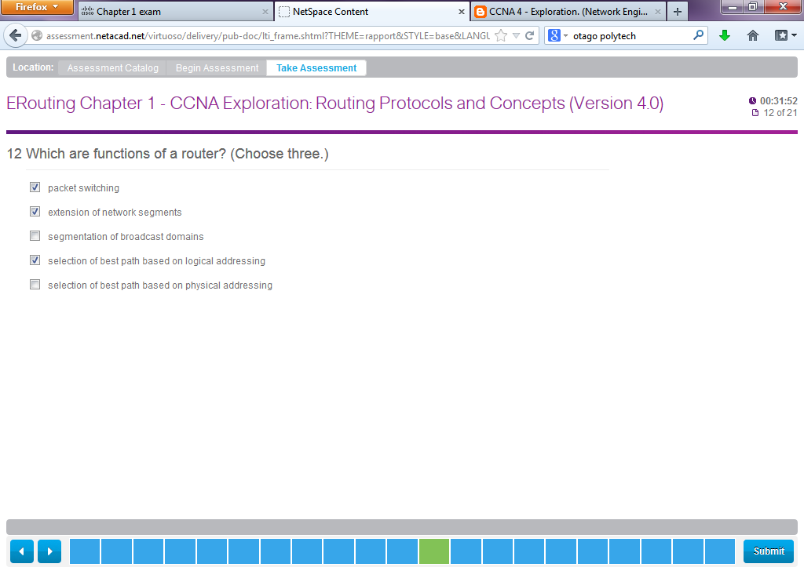

cORRECT Answer

8. Which are functions of a router? (Choose three.)

--> packet switching

--> segmentation of broadcast domains

**--> selection of best path based on logical addressing**

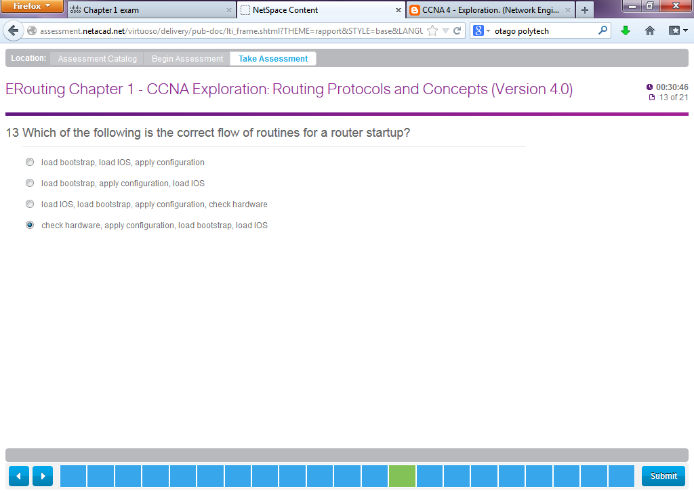

Correct Answer

**14.** Which of the following is the correct flow of routines for a router startup?

--> load bootstrap, load IOS, apply configuration

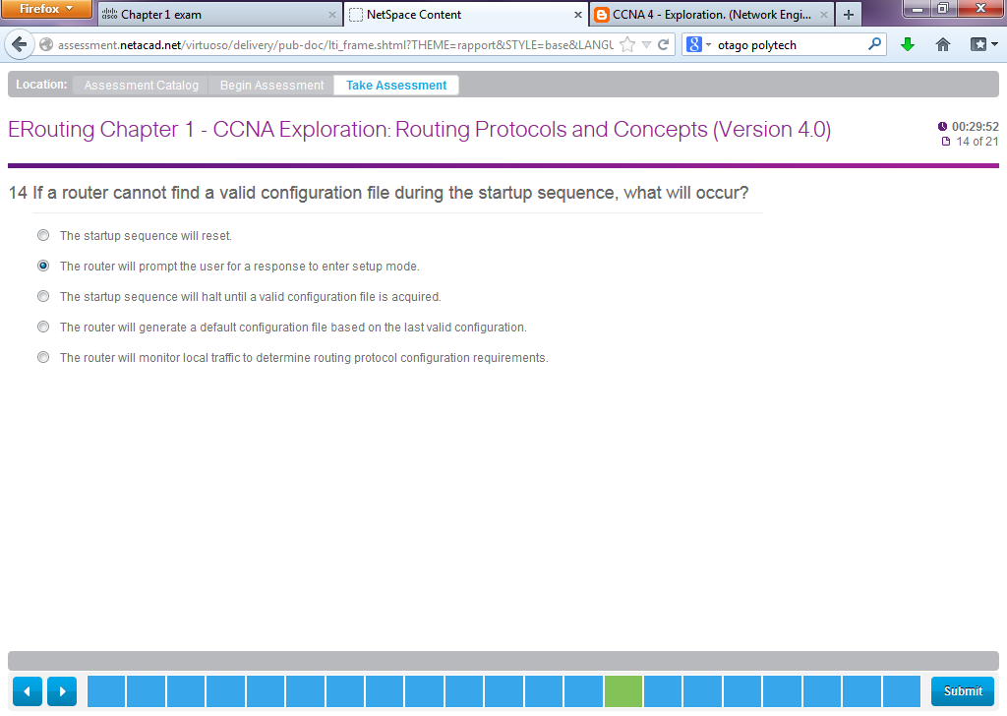

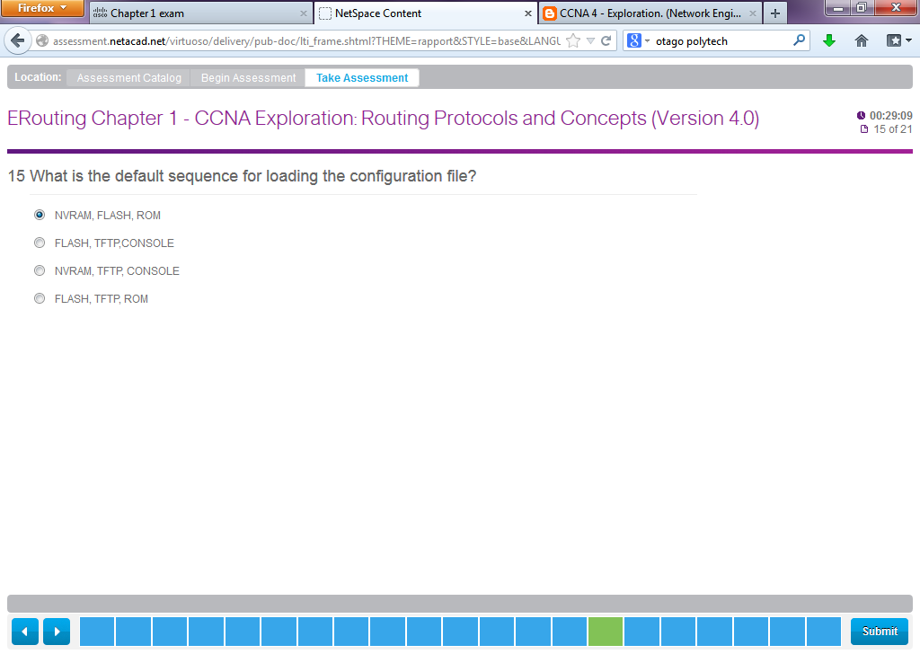

Correct Answer

22. What is the default sequence for loading the configuration file?

**-->** NVRAM, TFTP, CONSOLE

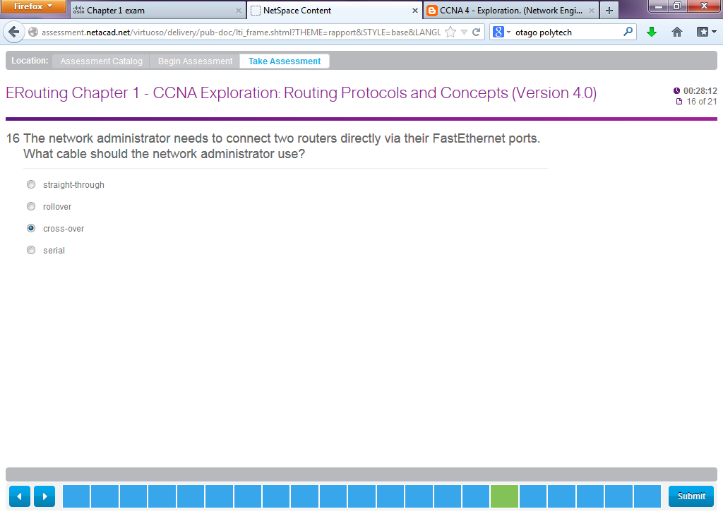

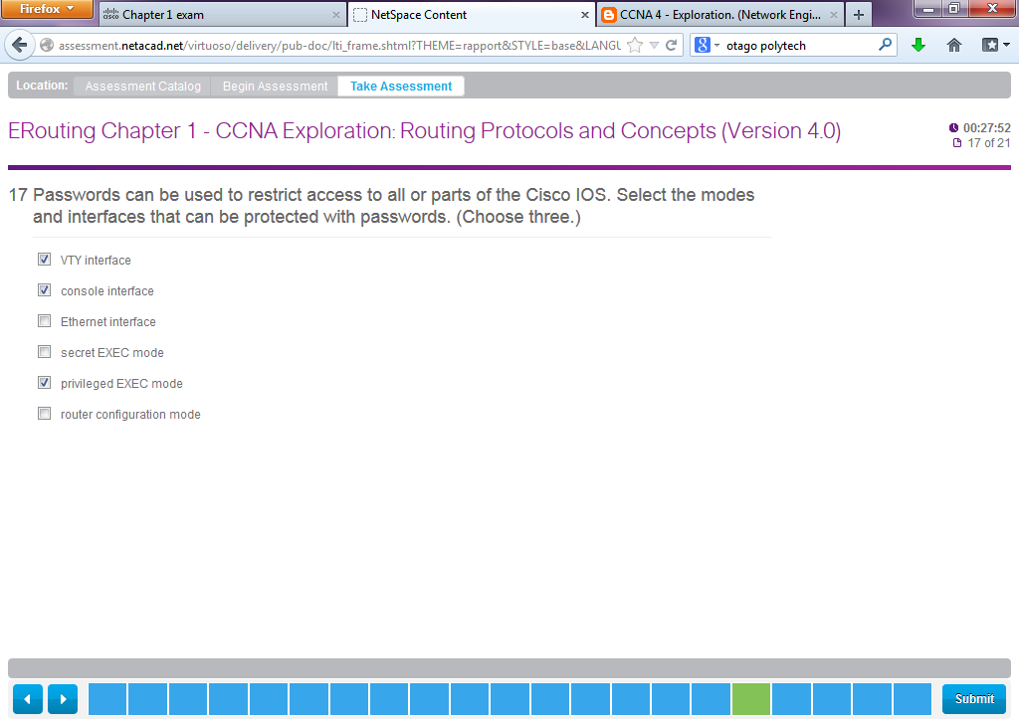

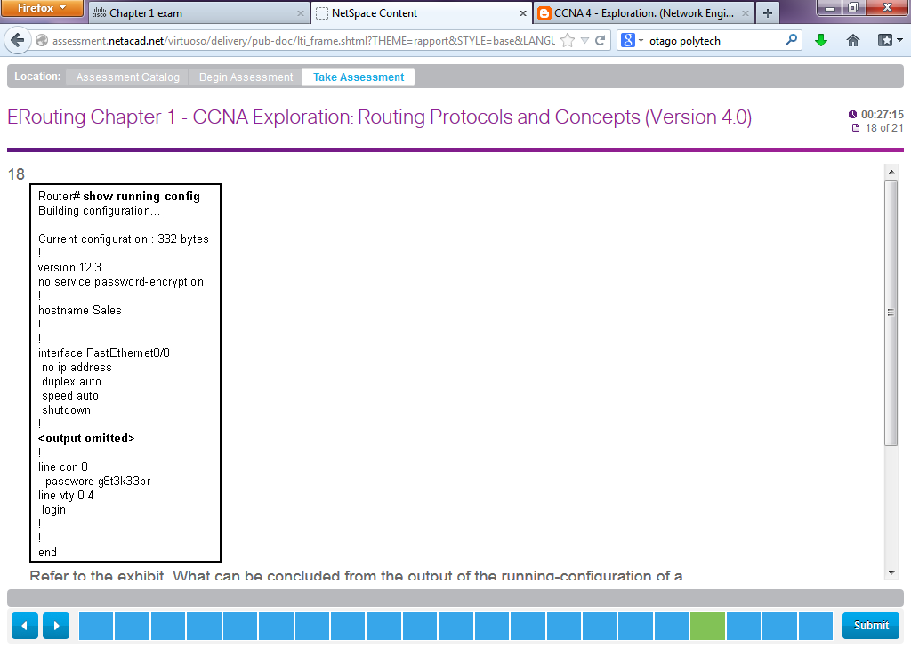

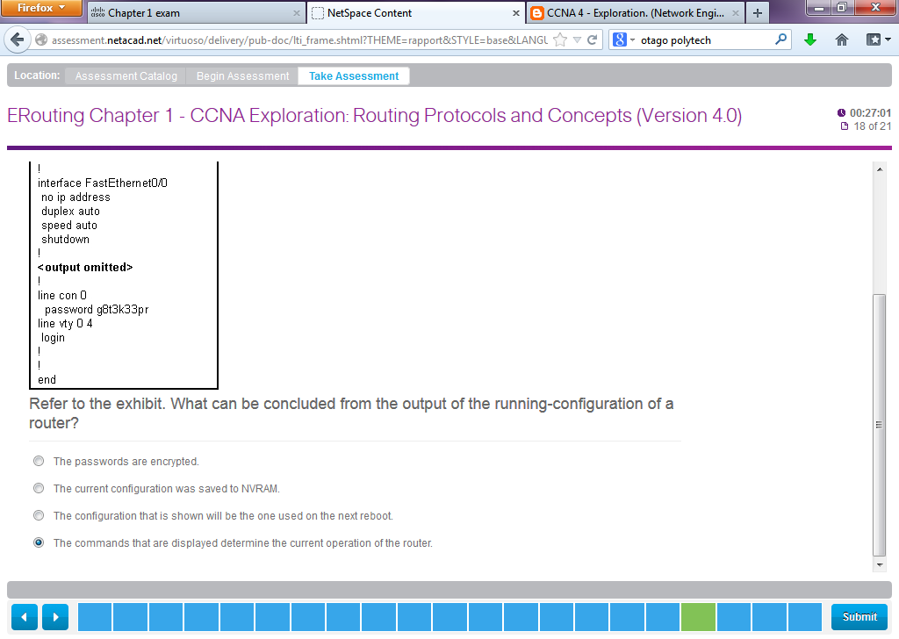

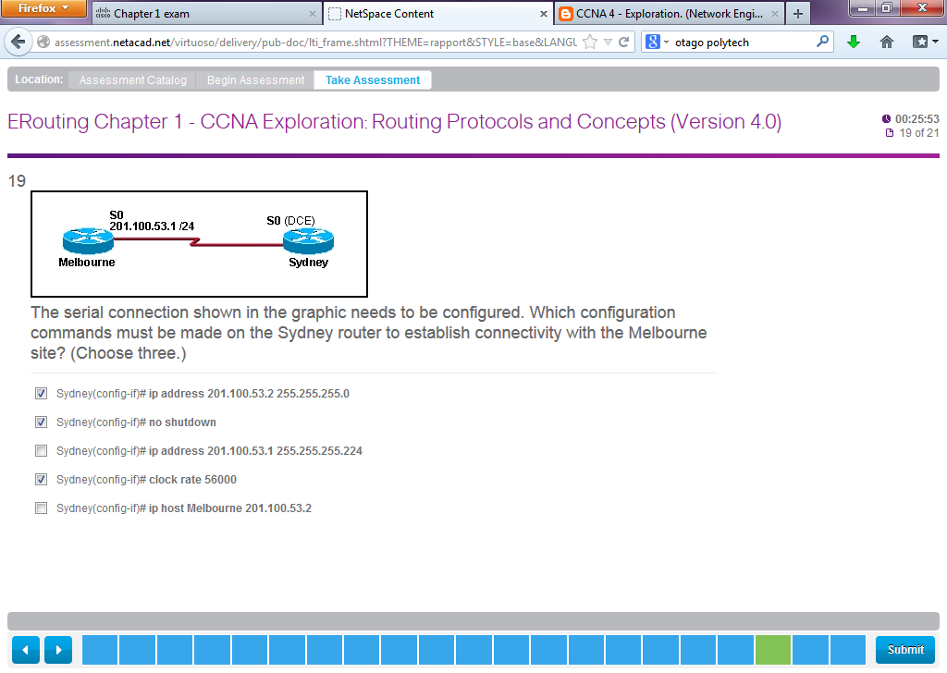

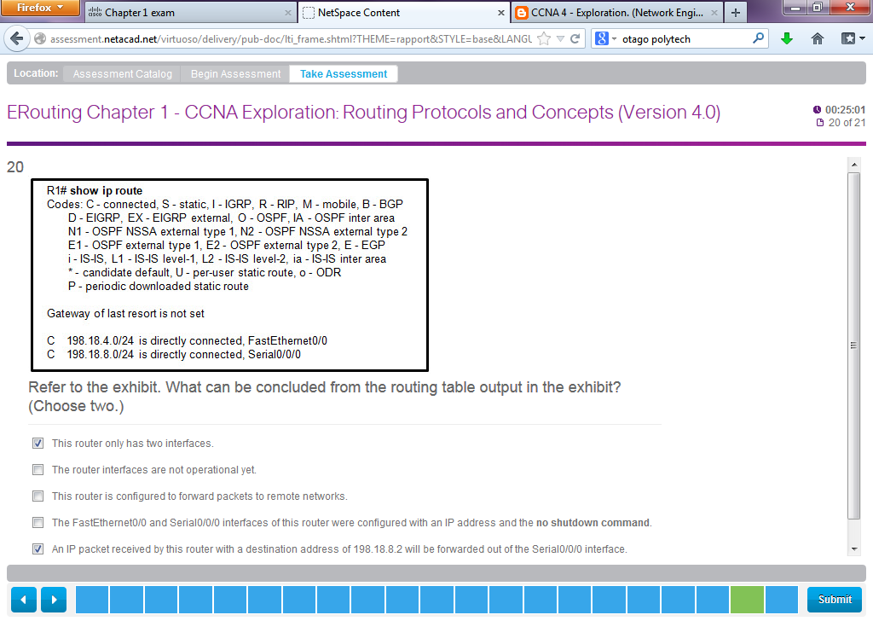

Correct Answer

3. Refer to the exhibit. What can be concluded from the routing table output in the exhibit? (Choose two.)

--> The FastEthernet0/0 and Serial0/0/0 interfaces of this router were configured with an IP address and the no shutdown command.

--> An IP packet received by this router with a destination address of 198.18.9.1 will be forwarded out of the Serial0/0/0 interface.

